 | BENCHMARK | RETEST 1 | RETEST 2 | RETEST 3
Single Leg Squats (L) | REPS | REPS | REPS | REPS
Single Leg Squats (R) | REPS | REPS | REPS | REPS
Plyo Press Ups | REPS | REPS | REPS | REPS
Toe Touches | REPS | REPS | REPS | REPS
Plyo Lunges | REPS | REPS | REPS | REPS
Burpees | REPS | REPS | REPS | REPS
Transition Plank | M: S: | M: S: | M: S: | M: S:
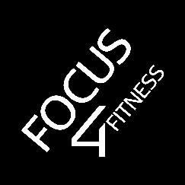
CoVi Challenge by Focus 4 Fitness - Advanced Level:

- Perform all exercises for 1 minute with no rest. The last exercise, Transition Plank, is held for as long as possible.
- No rest in between exercise except for writing down your score and resetting your stopwatch.
- Record your scores as you go along – we don’t want you forgetting.
- Keep this safe. Retest in 3-4 weeks and see how much you can progress in that time.
- Don’t forget to share your journey and your progress to win free training sessions!
GOOD LUCK!!

