 | BENCHMARK | RETEST 1 | RETEST 2 | RETEST 3
Jumping Squats | REPS | REPS | REPS | REPS
Press Ups | REPS | REPS | REPS | REPS
90 Degree Sit Ups | REPS | REPS | REPS | REPS
Lunges | REPS | REPS | REPS | REPS
Stand Burpees | REPS | REPS | REPS | REPS
Forerm Plank | M: S: | M: S: | M: S: | M: S:
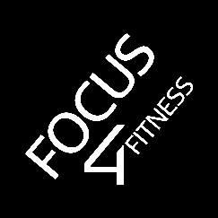
CoVi Challenge by Focus 4 Fitness - Intermediate Level:

- Perform all exercises for 1 minute with no rest. The last exercise, Forearm Plank, is held for as long as possible.
- No rest in between exercise except for writing down your score and resetting your stopwatch.
- Record your scores as you go along – we don’t want you forgetting.
- Keep this safe. Retest in 3-4 weeks and see how much you can progress in that time.
- Don’t forget to share your journey and your progress to win free training sessions!
GOOD LUCK!!

